Experiment Using Figma tool

NAME : A SREENATH

REG NO: 192525119

COURCE : SOFTEWARE ENGINEERING

Sketch a Simple Prototype of a Bus Ticket Booking System using Figma Tool

Aim
To design a basic bus ticket booking prototype using Figma.

Procedure
- Open Figma.
- Create a mobile frame.
- Add Login, Search, Seat Selection, Payment and Ticket screens.
- Connect screens using Prototype mode.
- Preview the prototype.

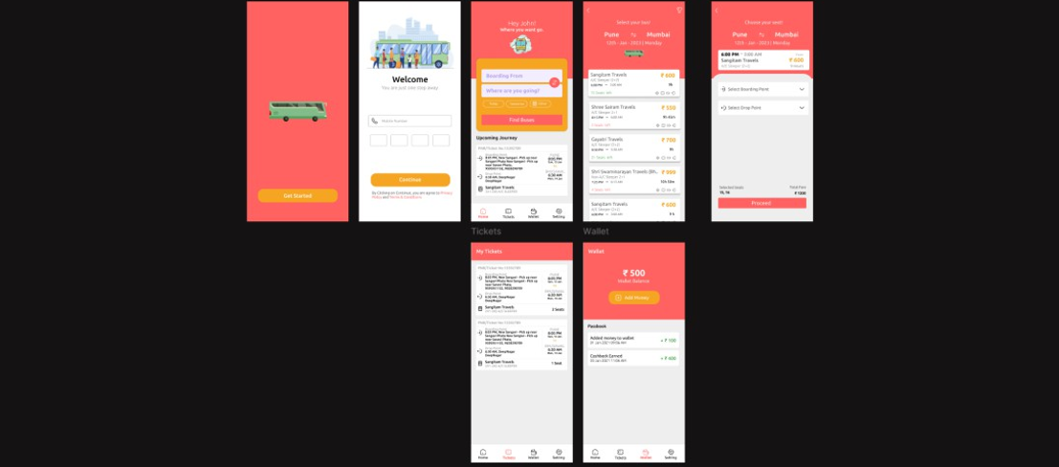Output Image

Result
Successfully created a simple interactive bus ticket booking prototype.

Prototype of an E-Commerce Mobile App using Figma for Stakeholder Feedback

Aim
To create an e-commerce app prototype and gather stakeholder feedback.

Procedure
- Open Figma.
- Create Home, Product, Cart and Checkout screens.
- Add navigation links.
- Present prototype to stakeholders.
- Collect feedback and revise design.

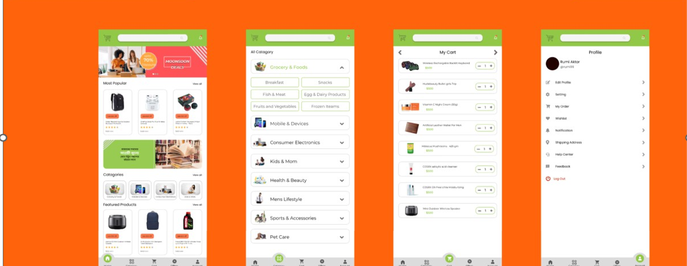Output Image

Result
Successfully created an interactive e-commerce prototype for stakeholder review.

